|  |  |
| --- | --- |
| NAME: | ABHINAV KUMAR SINGH |
| ROLL NO: | 20IM30032 |

**ASSIGNMENT-4 (OR LAB)**

**Solution1 :**

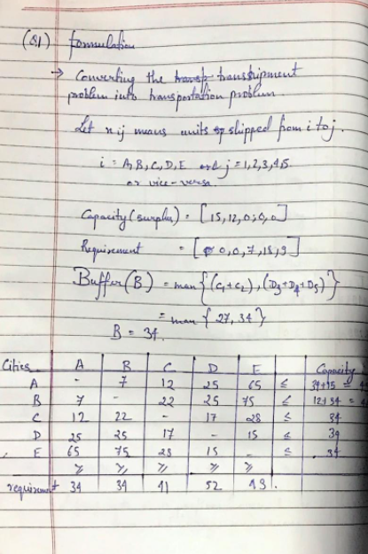

**Mod file:**

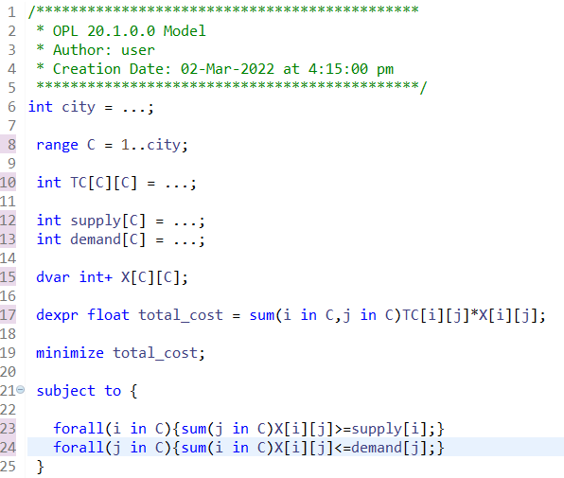

**.dat file:**

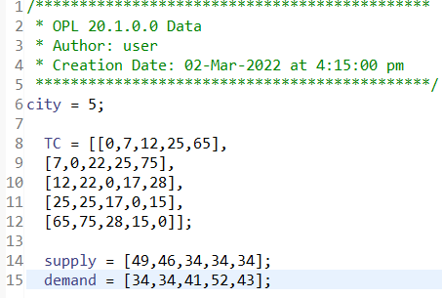

**Problem browser & Solution browser:**

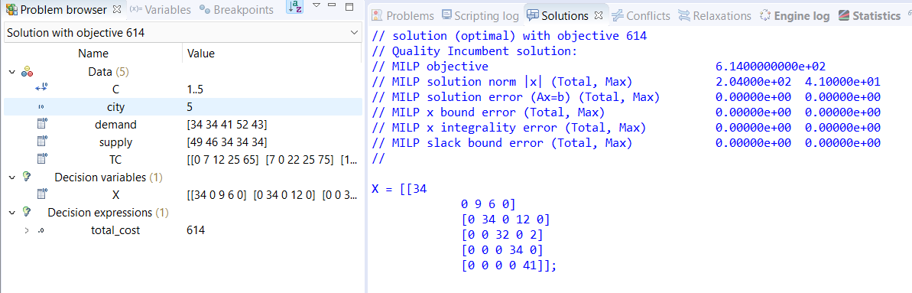

**Solution 2:**

**Mod file:**

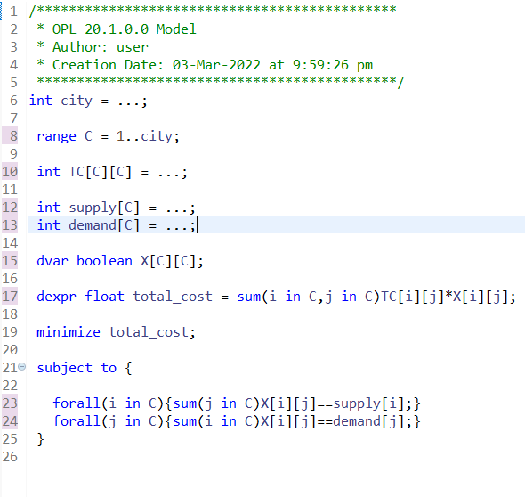

**.dat file:**

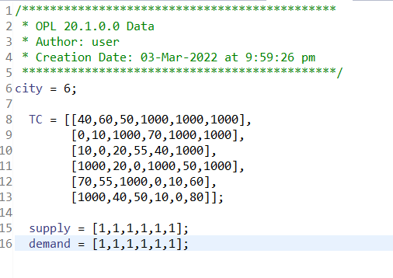

**Problem browser & Solution:**

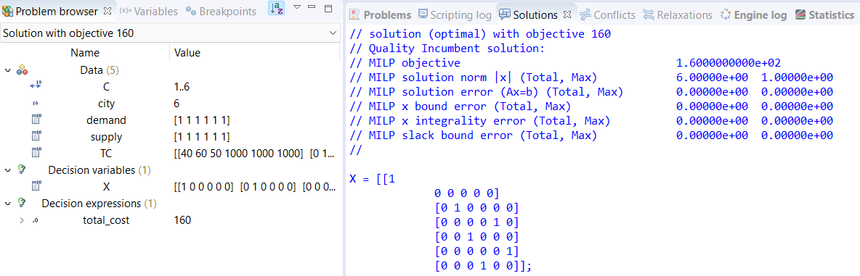

**Solution 3:**

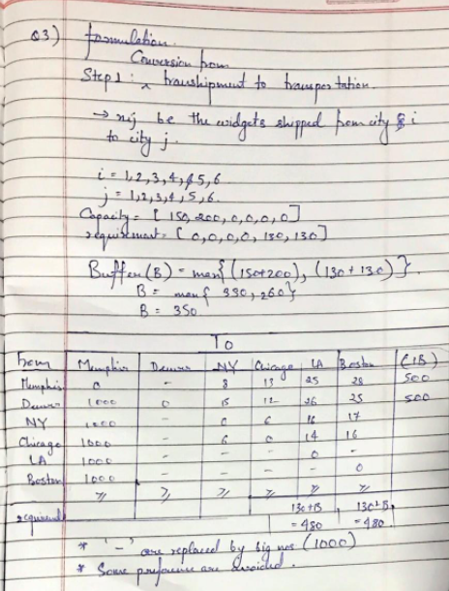

**Mod file:**

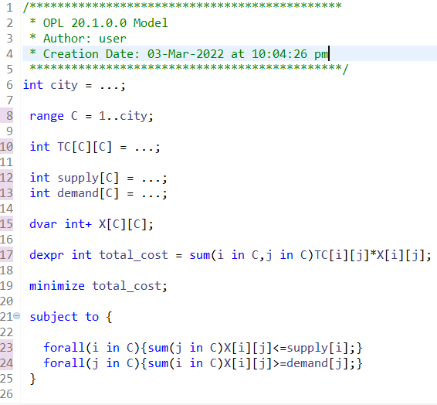

**.dat file:**

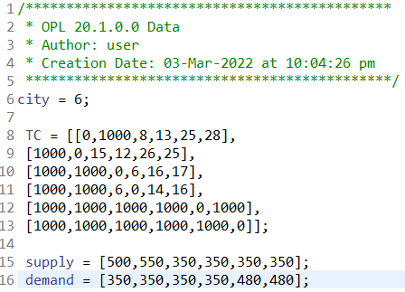

**Problem browser & Solution browser:**

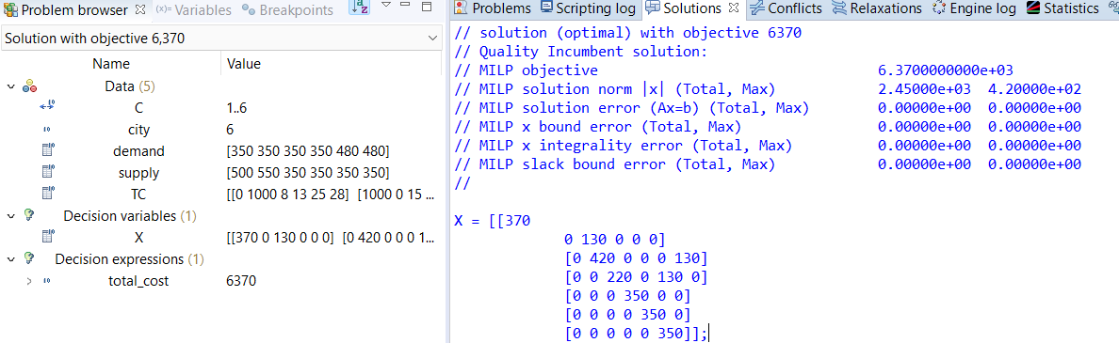

**Solution4:**

**Mod file:**

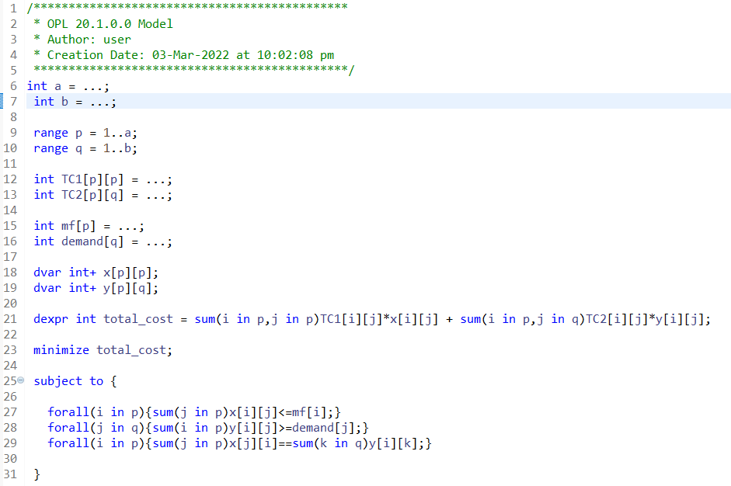

**.dat file:**

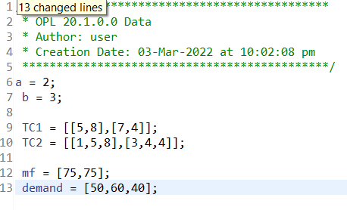

**Problem browser & Solution browser:**

